PROPOSALS TO BE CONSIDERED BY THE I.S.D.R.A. BOARD OF DIRECTORS

ISDRA Junior Dryland Race Category Proposal- Sanctioning Requirements and Standards – Junior Divisions

Submitted by Lauren Stierman, Junior Committee Chairperson

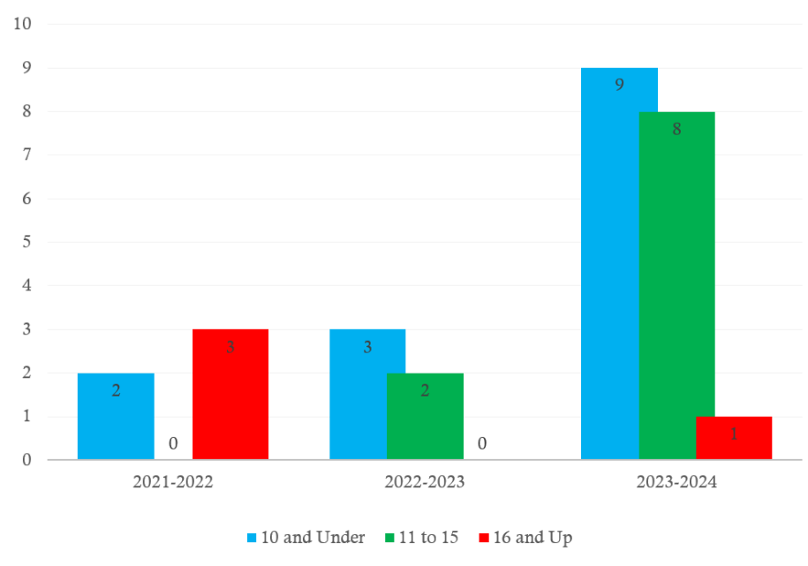We have seen a substantial increase in interest and participation of Junior membership this year (Figure 1). In an effort to continue the growth of membership and junior participation, these changes are put forth to bring everyone into alignment and celebrate our youth in the most effective way possible for the 2024/2025 season and going forward.

Figure 1: Active Junior Membership by Year

This proposal addresses ISDRA policy and procedure changes, as well as RGO impact and involvement going forward. Juniors class categories, structure and championship requirements will be broken up, as follows:

Juniors will remain considered to be under the age of 16 years at the Oct 1st season start. Juniors’ age categories will be broken up into two: 10 and under and 11-15. Each age category will be broken up into two race class categories: Canicross and Wheeled (1-2 dog for 10 and under, and 1-3 dog for 11-15) Parents would be responsible for selecting proper equipment and team size for their junior’s comfort level.

In accordance with the above, I propose the changes to the following documents:

PART I- Junior Program Sanctioning Requirements and Standards (changes to the document include):

A. RACE-GIVING ORGANIZATION’S RESPONSIBILITIES

1. At any sanctioned event, ~~Juniors may compete in either the Adult Division or the Junior Division, but not both, for a race of a specific competition ‘Type’ (sled, gig, skijoring). Additionally, racing in the Junior Division for one competition ‘Type’ does not bar the Junior from racing in the Adult Division for a different competition ‘Type.’~~

~~Example. A Junior may compete in a Junior Sled race and an Adult Skijoring race at the same event. However, he/she may not compete in both Adult and Junior Sled races at the same event.~~

Juniors considered 15 and under at the Oct 1st start of the season may not compete in any adult division class.

1. Both age divisions will be seeded into the Start Times together (in accordance with how AB Pro, RB Pro and Novice classes get seeded into one class start time)
   1. Juniors in the 11-15 age division will be seeded randomly followed by randomly seeding the 10 and underage division.
      1. Organizations may seed the Wheeled class in by ‘Type’ if they choose to reach out to registrants’ parents in advance and get their intended race vehicle. In this instance, an organization should seed in as follows: Rig, Bike, Scooter.
   2. Finish results should then be separated into the two age divisions (10 and under and 11-15) by class (similar to how AB Pro, RB Pro and Novice are separated by “group” for results).

B. APPLYING FOR SANCTIONING

1. Classes which qualify for ISDRA Junior Sanctioning are:
   1. Speed Races
      1. Limited ~~Four (4)~~ One (1) Dog Canicross Class for 10 and under.
      2. Limited ~~Three (3)~~ One (1) Dog Canicross Class for 11-15.
      3. Limited ~~Two (2)~~ Two (2) Dog Wheeled Class for 10 and under.
      4. Limited ~~One (1)~~ Three (3) Dog Wheeled Class for 11-15.

C. SANCTIONING FEES

2. ~~An event with one (1) or more senior ISDRA sanctioned class(es) will pay a fee of Five dollars ($5.00) for each Junior Sanctioned class.~~ All applicable Juniors classes are automatically sanctioned by ISDRA in the event that one (1) or more adult ISDRA class(es) are sanctioned and Organizers will pay No Fee for each Junior Sanctioned class.

E. CRITERIA FOR MEDAL STATUS

1. ~~Six events per recognized class in a single year.~~
2. ~~Must take place in a minimum of two (2) countries and three (3) states or provinces.~~
3. ~~The minimum number of competitors for the first year of attempted entry into the medals program shall be at least three (3) times the number of medals to be awarded.~~
4. ~~The second year, the minimum number of competitors shall be at least five (5) times the number of medals to be awarded.~~
5. ~~The third year, the minimum number competitors shall be seven (7) times the number of medals to be awarded.~~
6. ~~The fourth year, the minimum number competitors shall be ten (10) times the number of medals to be awarded.~~
7. ISDRA Junior Medals and Certificates offered for placing in Sanctioned Events shall be awarded in accordance with the ISDRA Junior Championship Points Program regulations.

I. ISDRA MEMBERSHIP STATUS OF CONTESTANTS

~~2. The sponsoring organization needs to ascertain each participant’s membership standing with ISDRA~~

* 1. ~~Each member shall be provided with an annual membership card as proof of current affiliation with the international organization.~~
  2. ~~An updated listing of ISDRA members may be obtained through the ISDRA Executive Office by organizations conducting sanctioned events.~~

~~4. Isdra membership shall be available at race sites.~~

~~5. Race organizations may assess and retain a surcharge of up to 15% for ISDRA memberships collected at race sites. The race organization must state the surcharge on advertising and/or entry forms.~~

1. ISDRA membership shall be available at race sites.
2. Race organizations may assess and retain a surcharge of up to 15% for ISDRA memberships collected at race sites. The race organization must state the surcharge on advertising and/or entry forms.

Part II- Junior Championship Points Program (changes to this document include):

ELIGIBILITY

ISDRA awards championship points to current ISDRA Junior Members competing in ISDSRA Sanctioned Races. Members eligible to earn points are Junior Members, ~~16~~ 15 years of age and younger. October 1st Shall be used to determine the Junior member’s eligibility for the following season.

MEDALS PROGRAM

Criteria for Medal Class qualification are as follows:

1. At least six (6) sanctioned races per class must take place in a single season.
2. These sanctioned races must take place in three (3) regions.
3. The minimum number of ranked junior competitors for each class and category shall be at least ~~nine (9)~~ six (6) for the entry into medal status.
4. To qualify for a medal in any class, a junior member must complete at least three (3) sanctioned races in that class.

The proposed rule changes would have a slight economic effect to ISDRA and possibly RGO’s, but are presented to provide standards to Junior members, their parents, and RGO’s. ISDRA would need to keep in mind both age divisions of Juniors (10 and under and 11-15) when ordering championship medals each year. RGO’s would be impacted by adding the four (4) new categories during registration (Canicross 10 and under, Canicross 11-15, 1-2 Dog Wheeled 10 and under, 1-3 Dog Wheeled 11-15), however they would continue to run all ages together for Canicross and for Wheeled. ISDRA will provide awards for all four (4) classes, but there could be economic impact for RGO’s who choose to order medals for juniors and include them in their own purse.

According to the Policy and Procedure D. 4., "Only written comments which are delivered to the Executive Director's Office will be considered by the Board of Directors when determining the final outcome of the proposal."

Please email Meredith Michener your comments at meredith.michener@isdra.org .

Sincerely,

Meredith Michener

Executive Director, ISDRA

Overall points seedings. Definitely keep randomized order that’s fair.

After 3 passing